**DML Statements**

1. Inserting Customer Table records

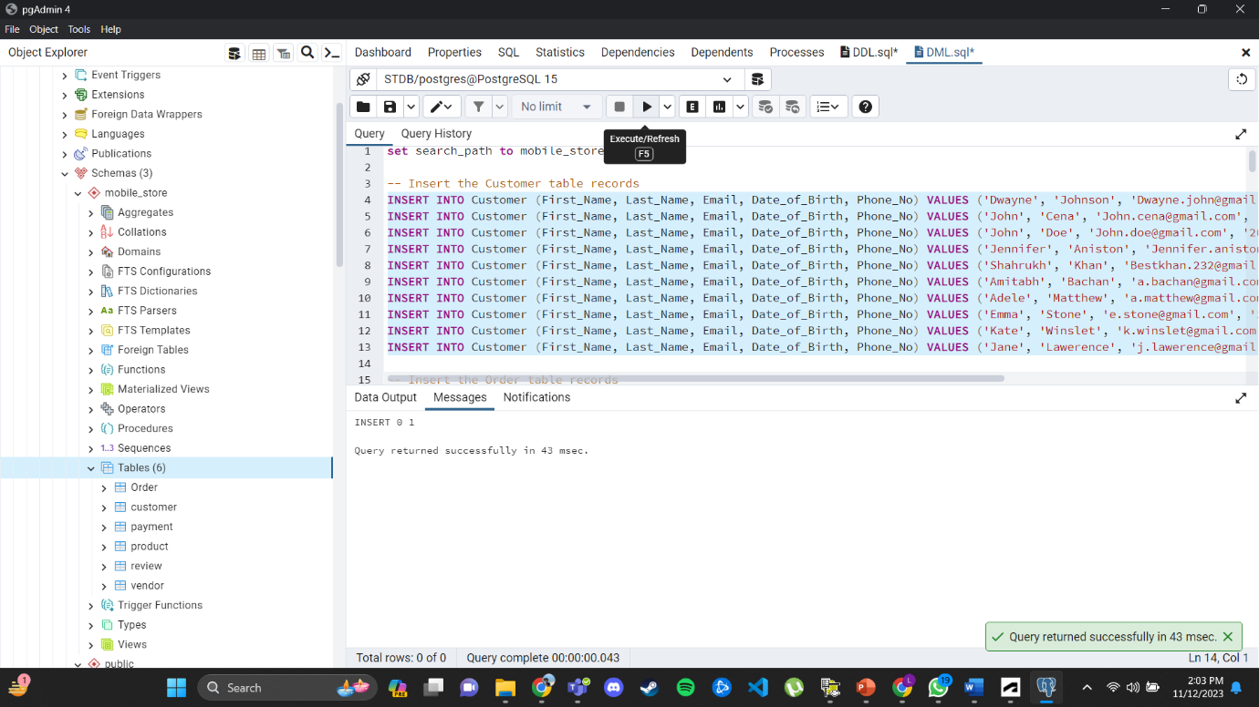

__________________________________________________________________________________

1. Inserting Order Table records

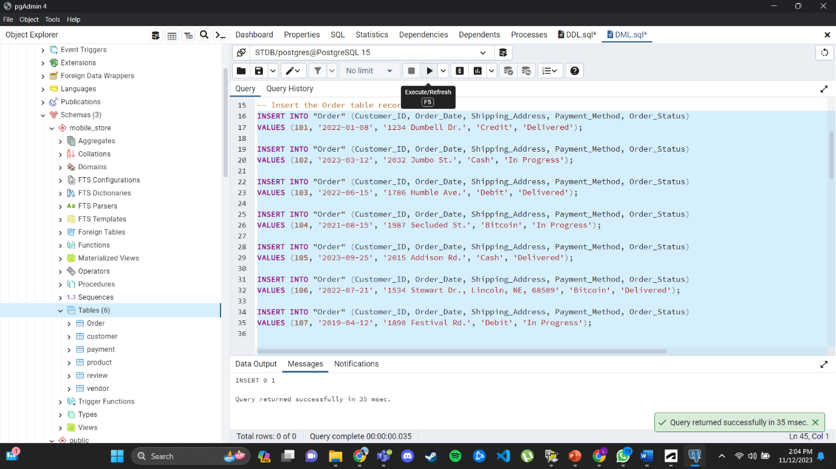

1. Inserting Vendor Table records

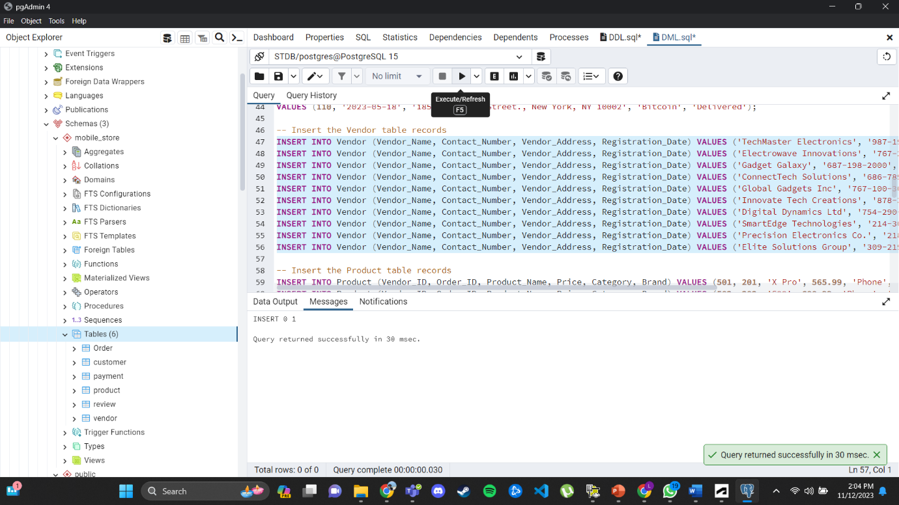

__________________________________________________________________________________

1. Inserting Product Table records

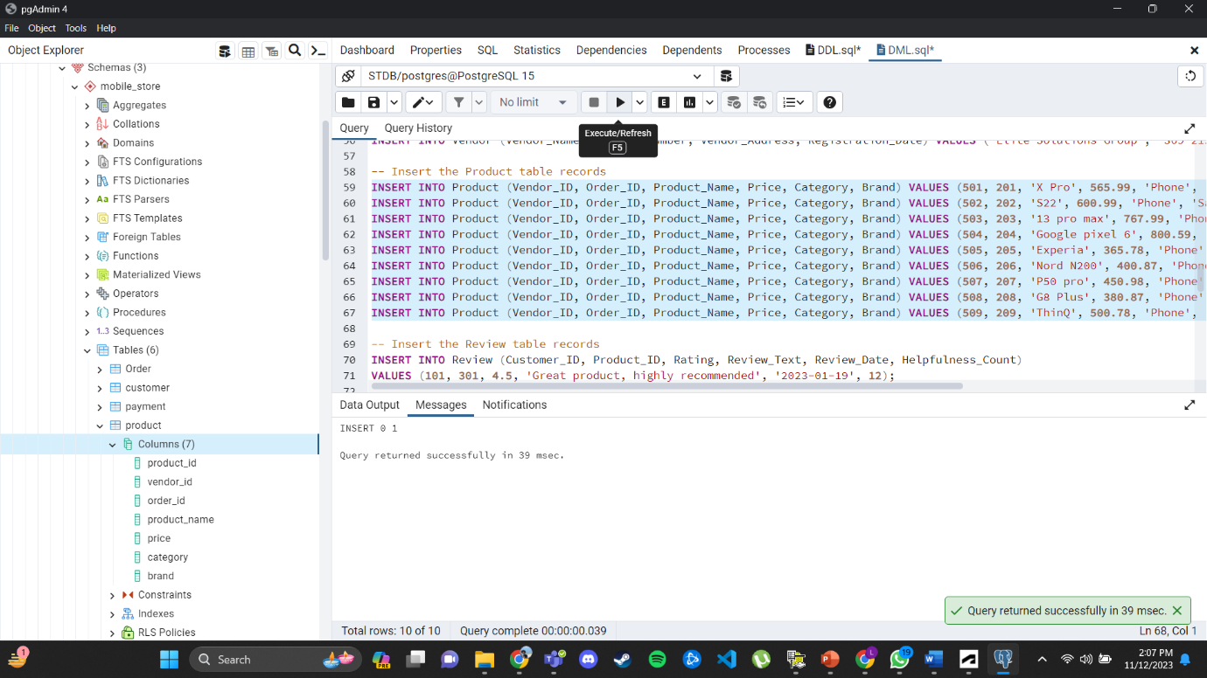

1. Inserting Review Table records

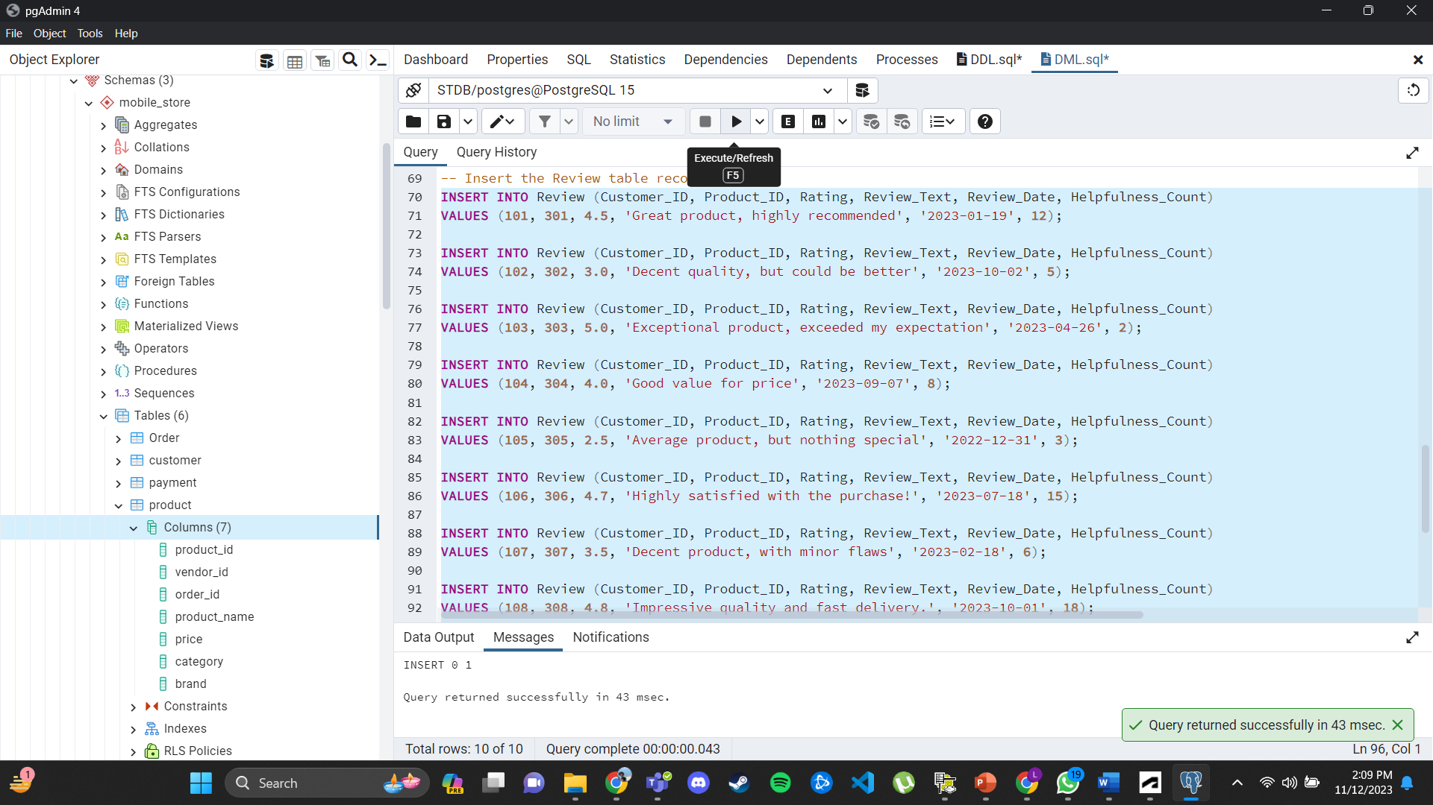

__________________________________________________________________________________

1. Inserting Payment Table records

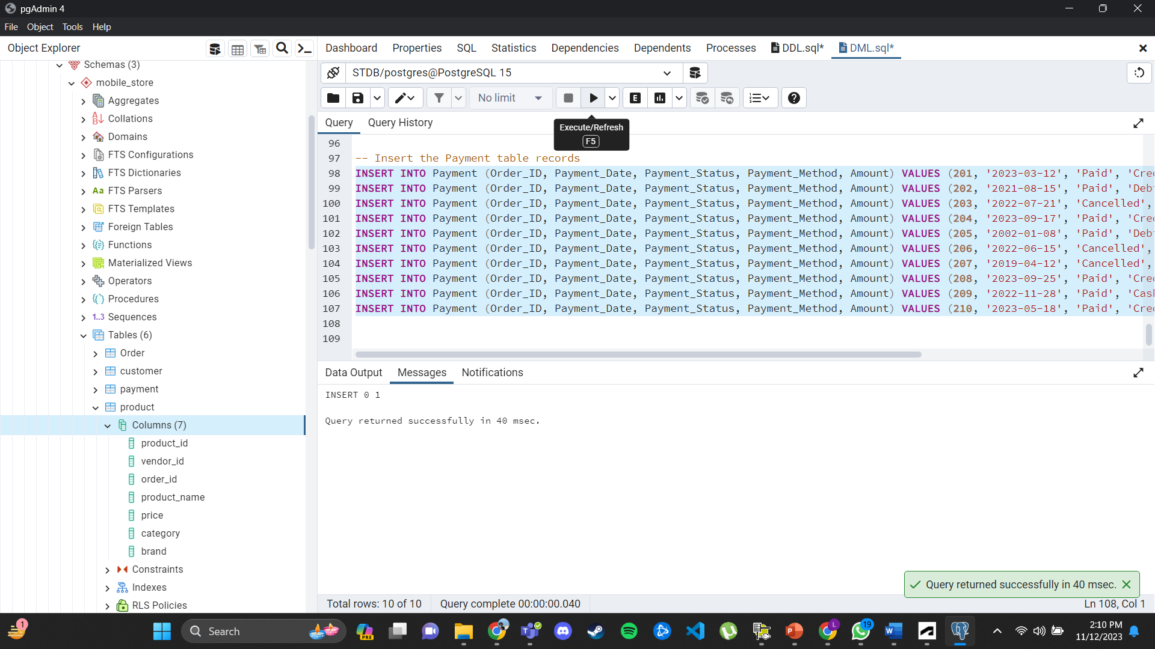

**12 Basic queries and 2 Advanced queries**

1. Query 1 - Select all columns and all rows from one table

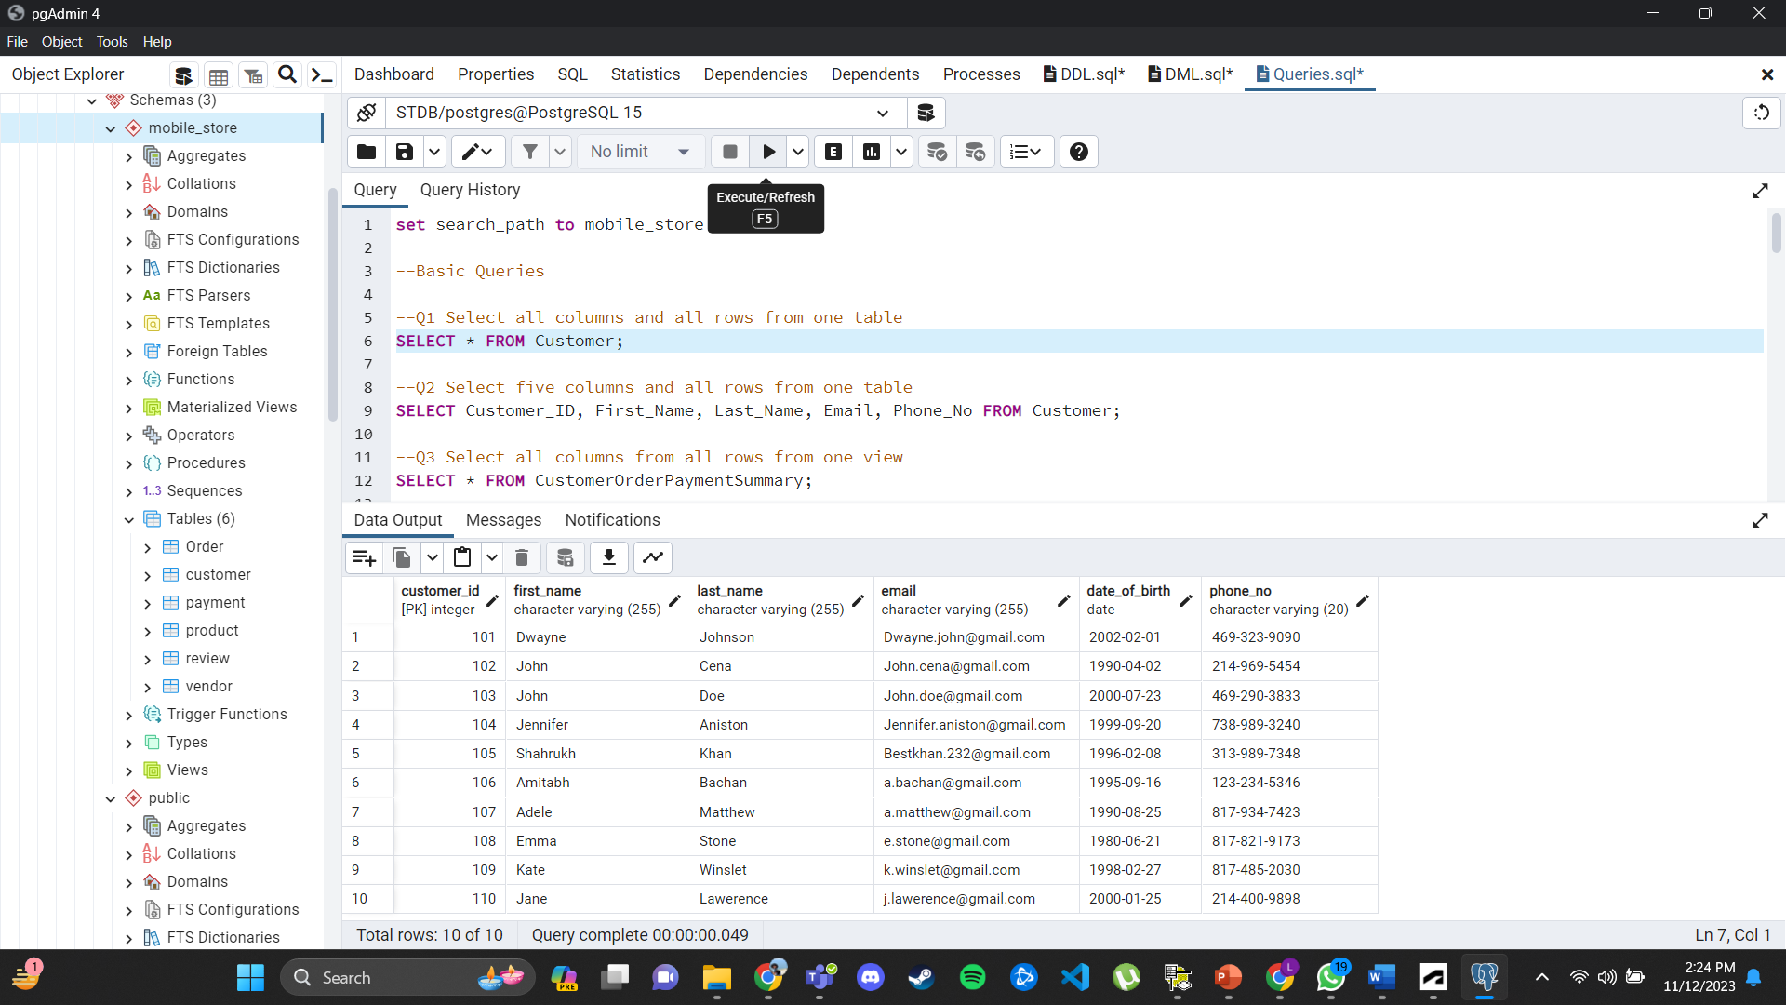

__________________________________________________________________________________

1. Query 2 - Select five columns and all rows from one table

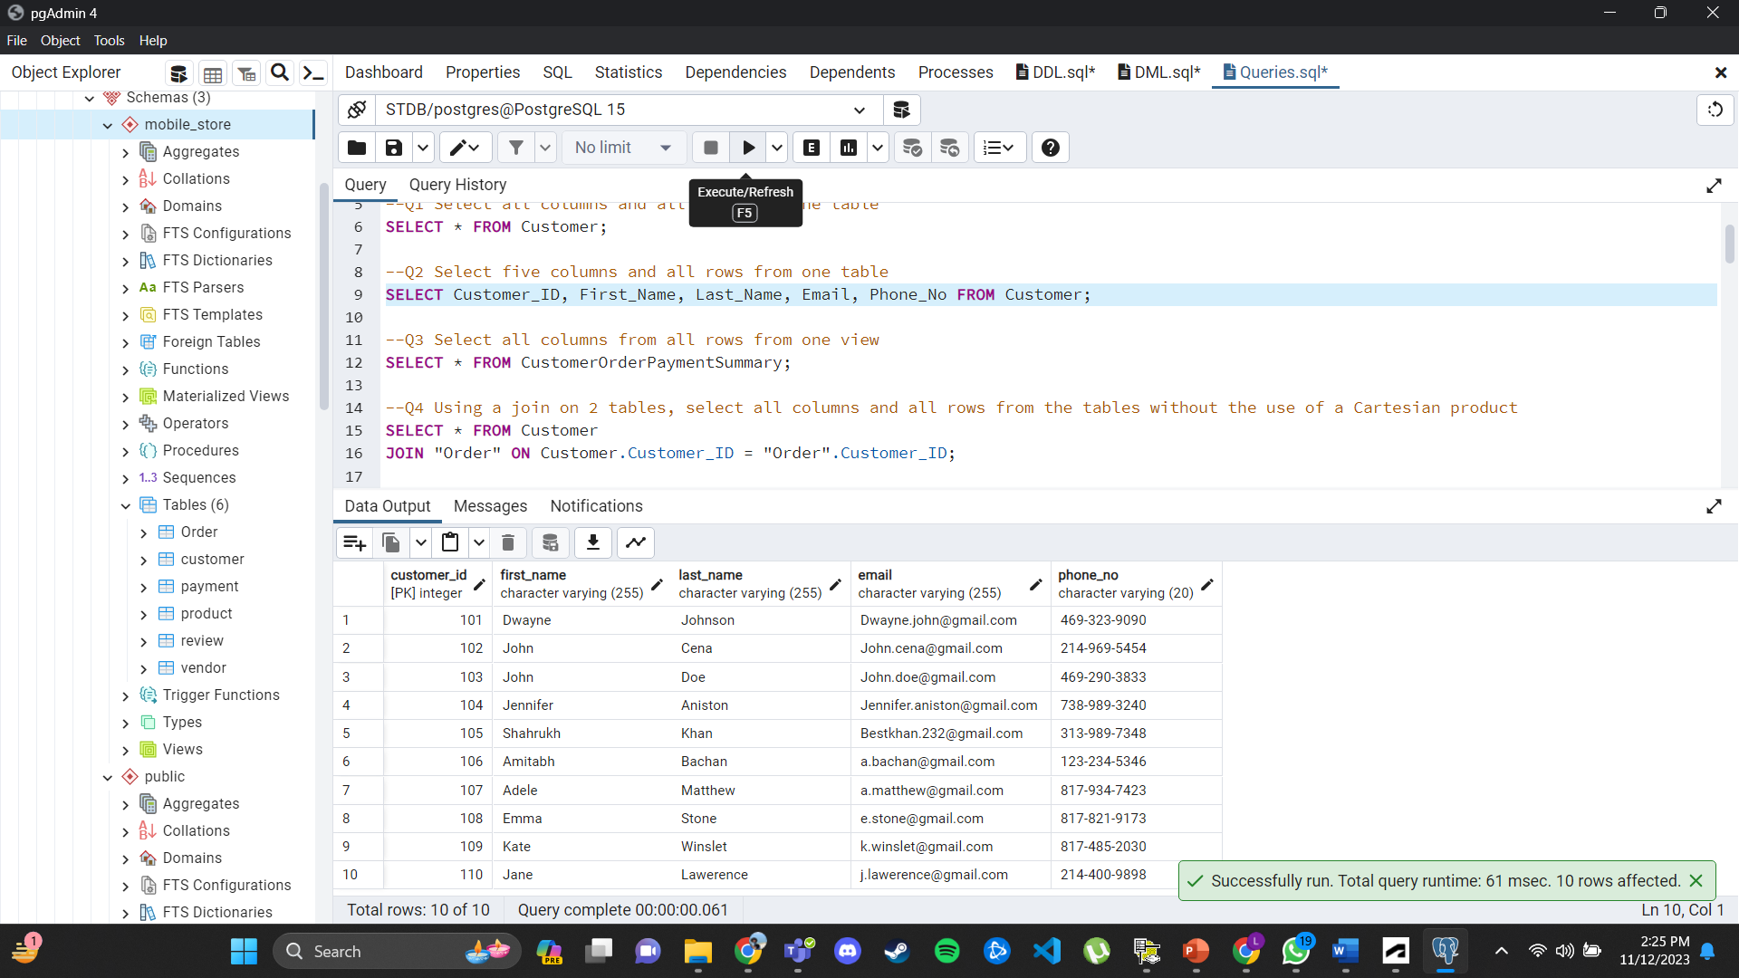

1. Select all columns from all rows from one view

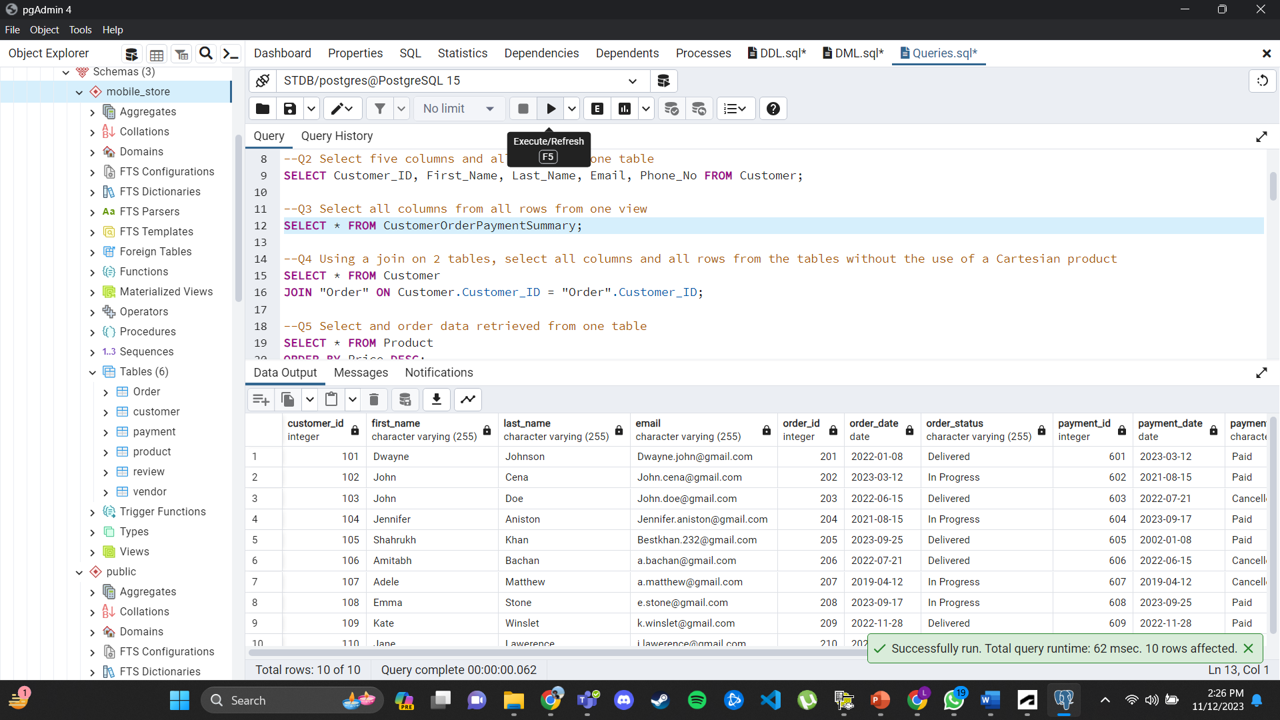

__________________________________________________________________________________

1. Using a join on 2 tables, select all columns and all rows from the tables without the use of a Cartesian product

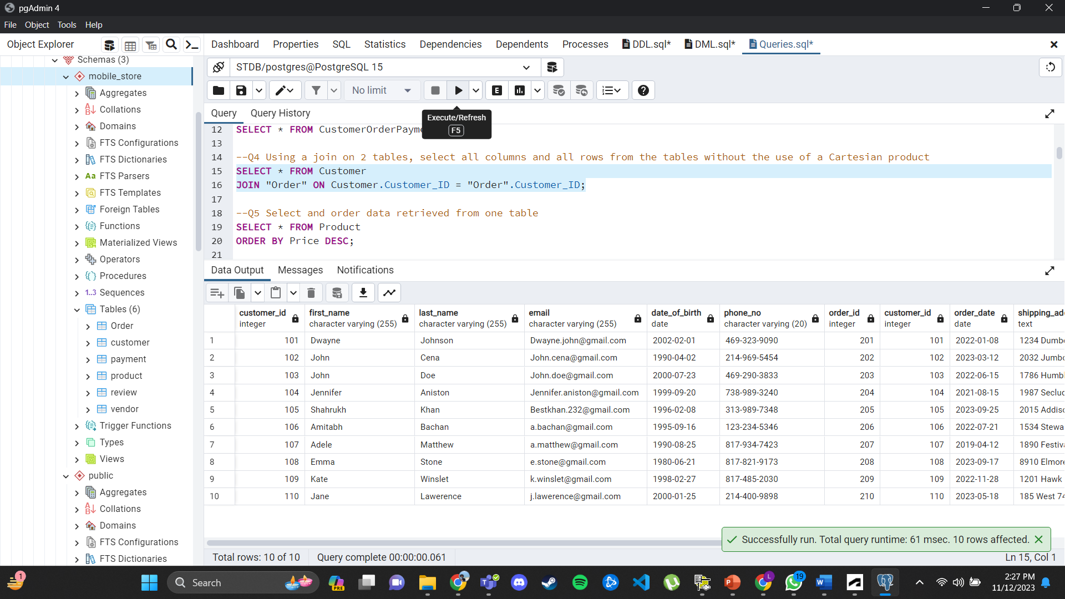

1. Select and order data retrieved from one table

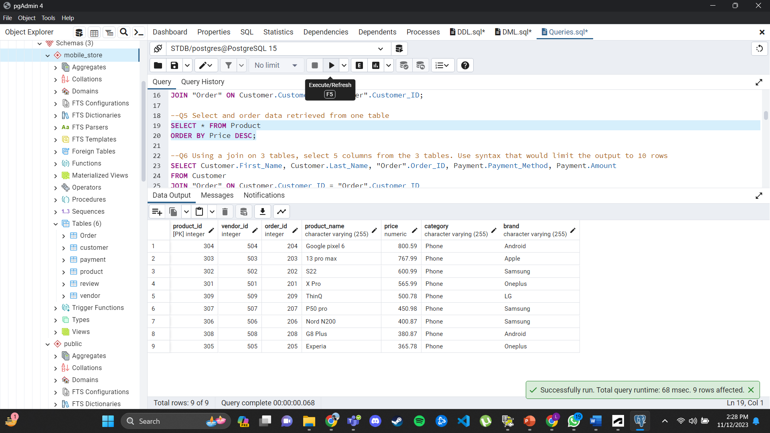

__________________________________________________________________________________

1. Using a join on 3 tables, select 5 columns from the 3 tables. Use syntax that would limit the output to 10 rows

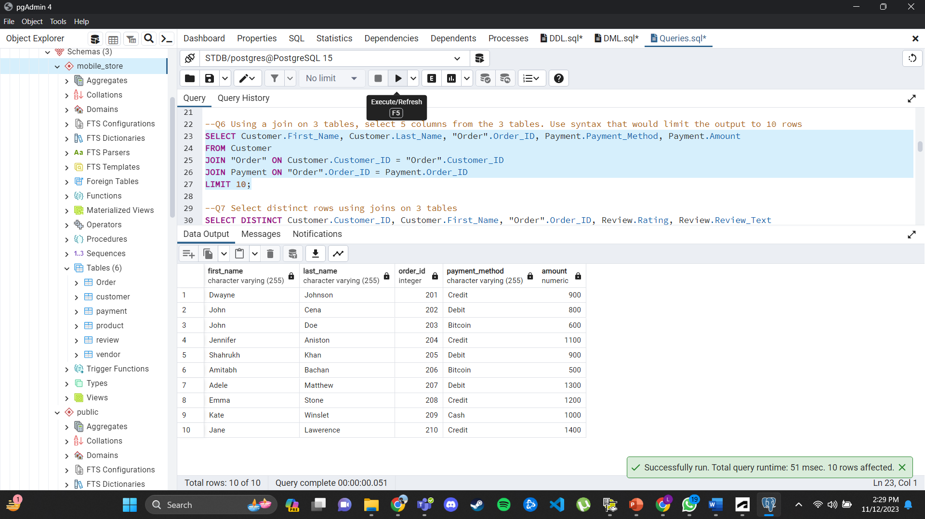

1. Select distinct rows using joins on 3 tables

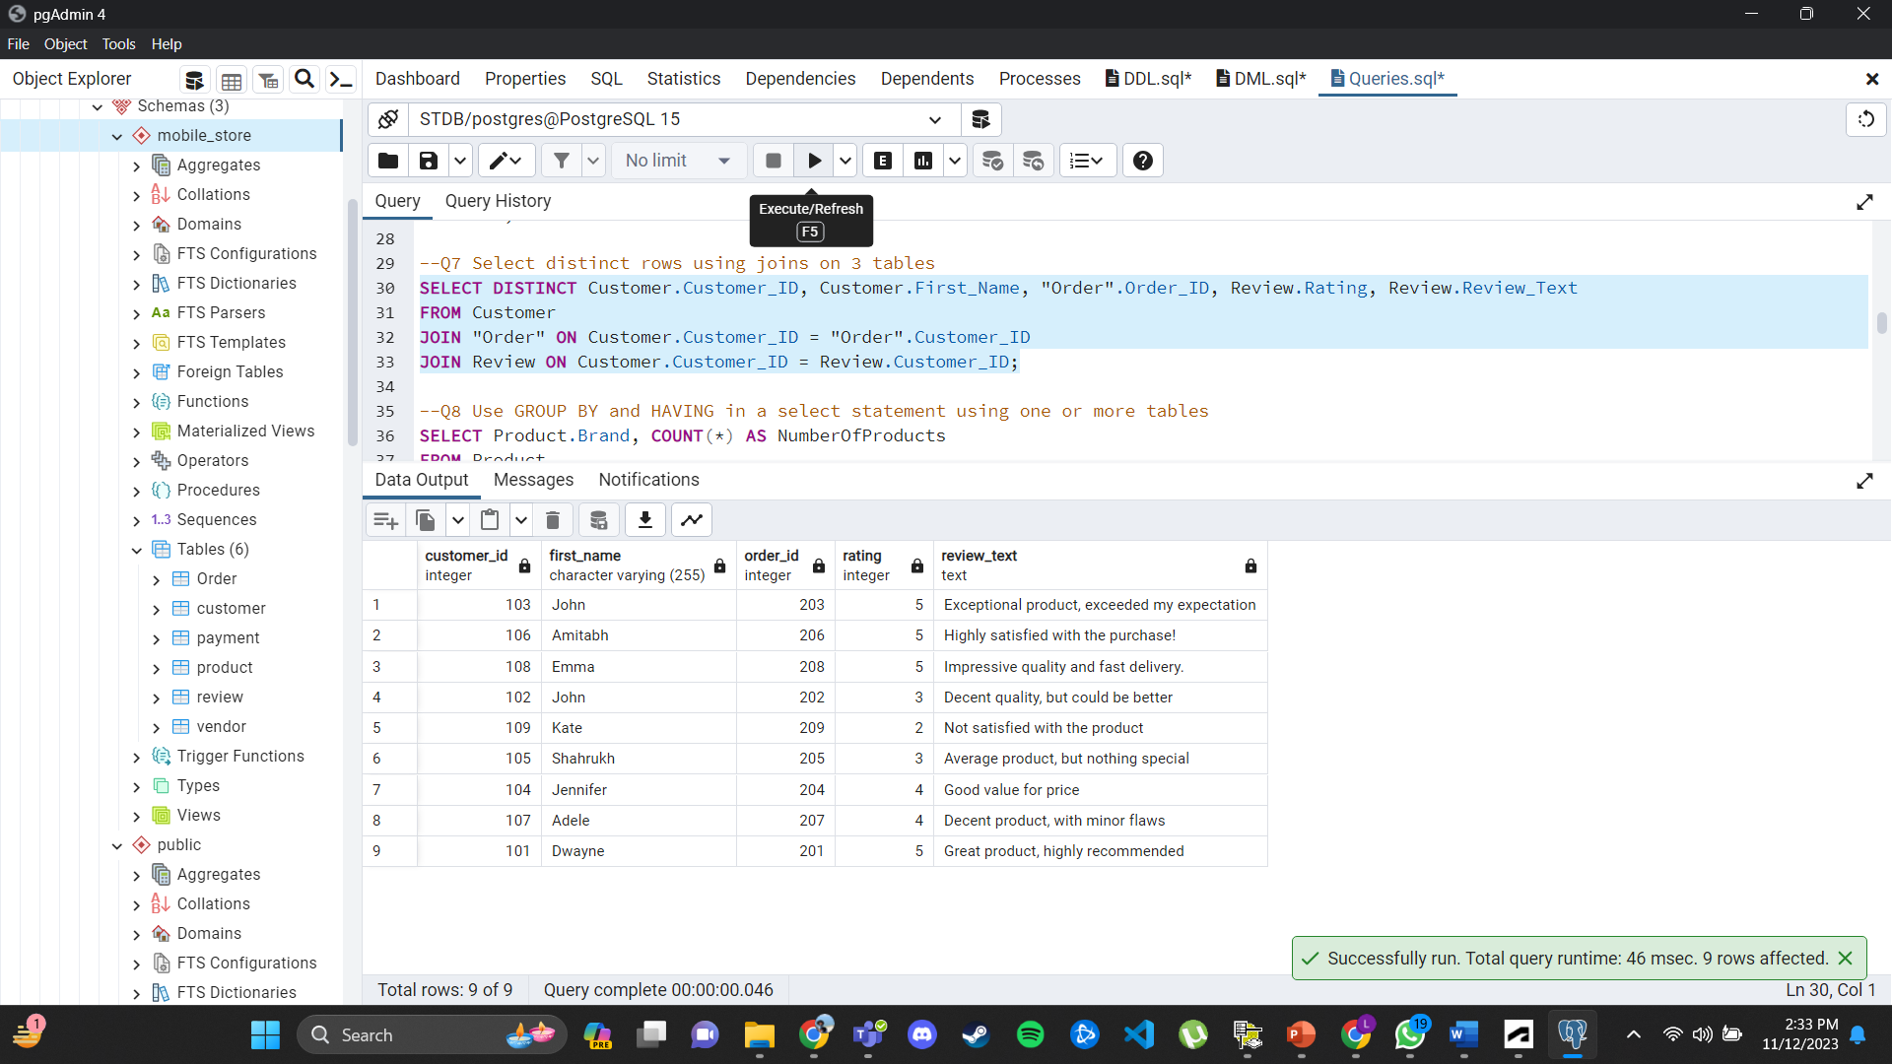

__________________________________________________________________________________

1. Use GROUP BY and HAVING in a select statement using one or more tables

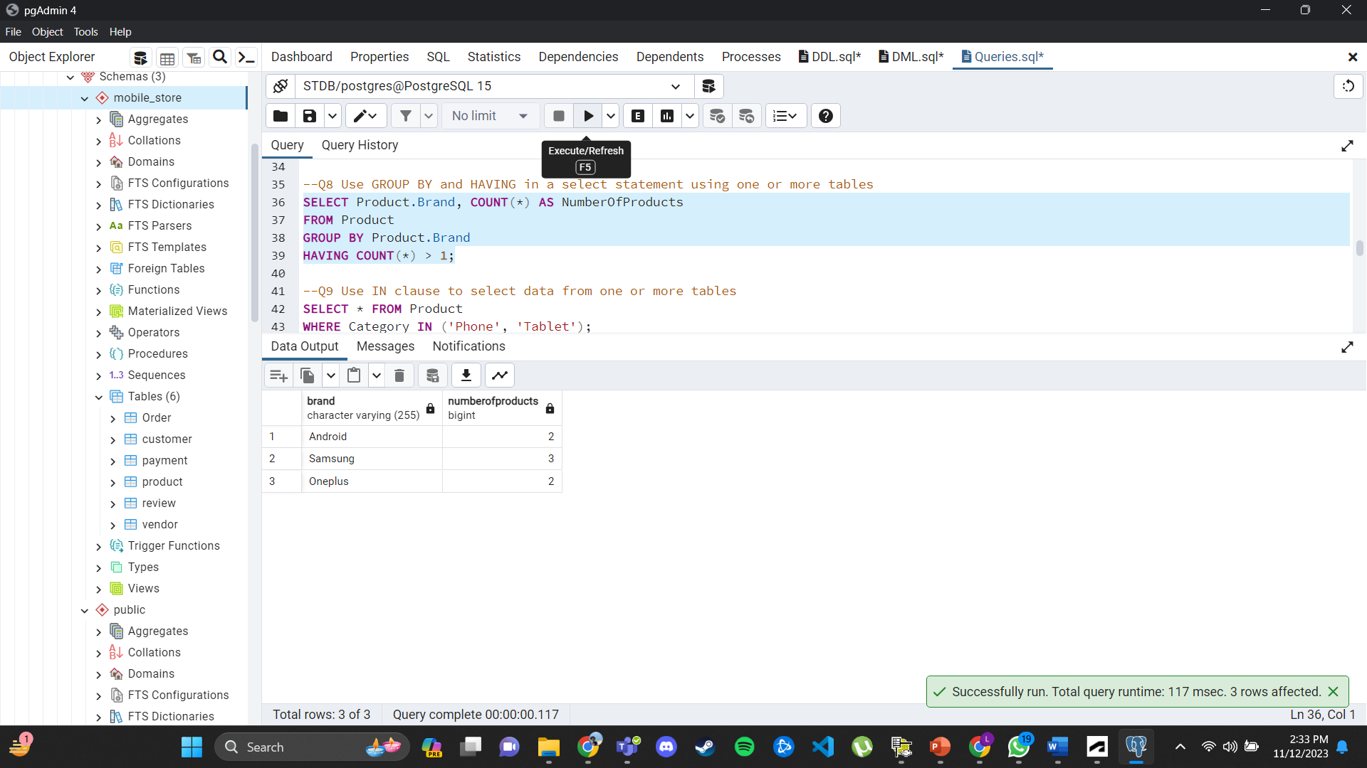

1. Use IN clause to select data from one or more tables

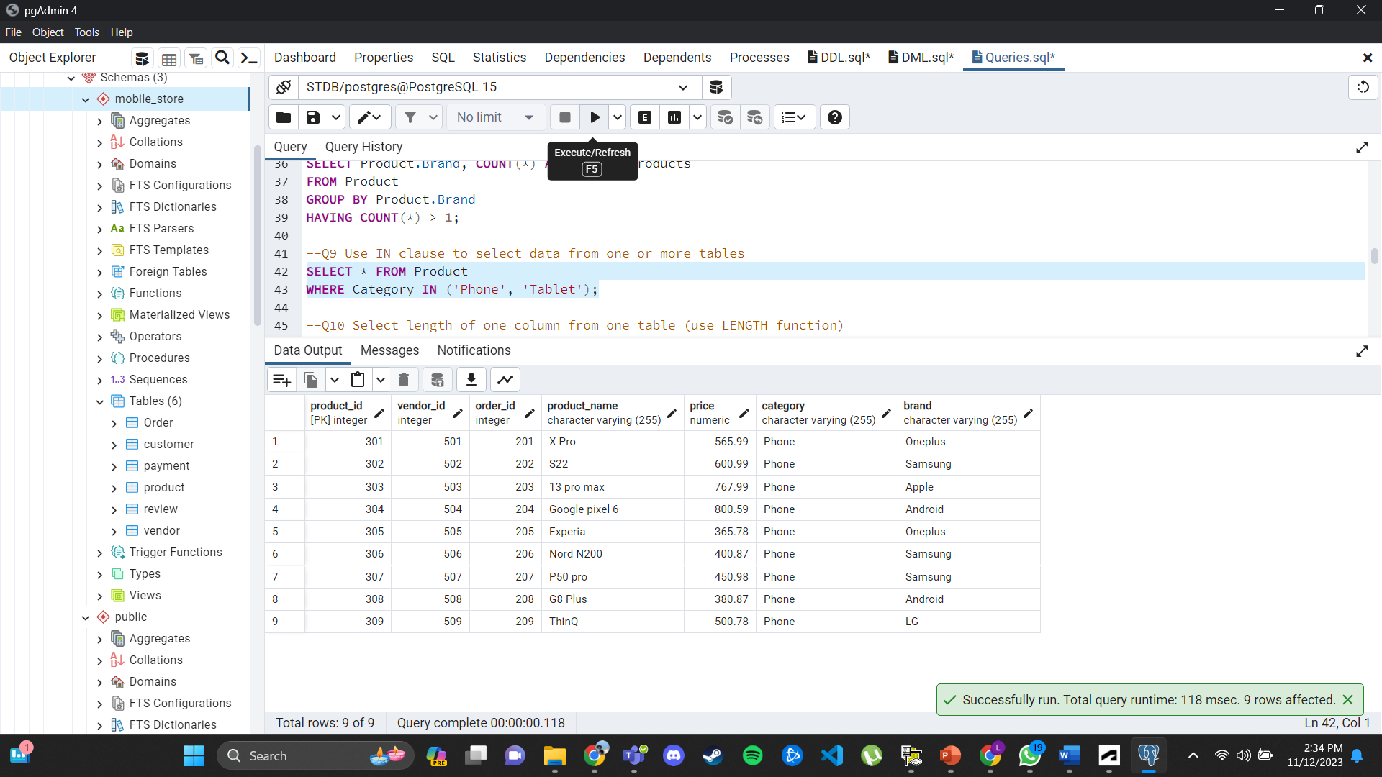

__________________________________________________________________________________

1. Select length of one column from one table (use LENGTH function)

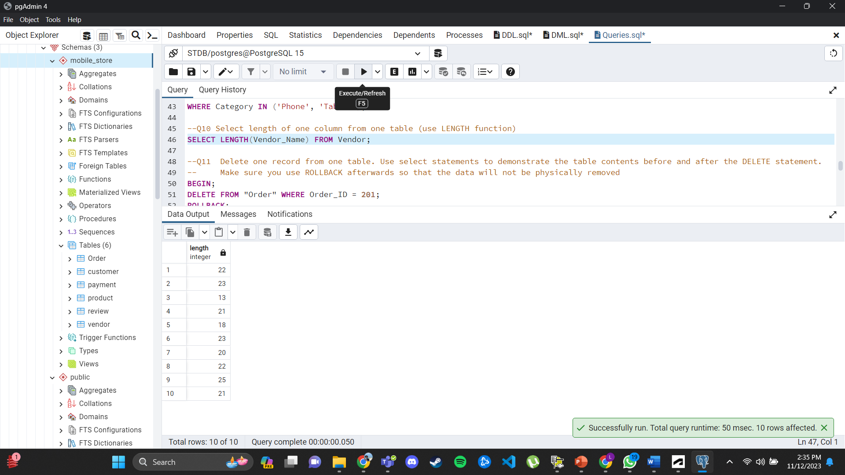

1. Delete one record from one table. Use select statements to demonstrate the table contents before and after the DELETE statement. Make sure you use ROLLBACK afterwards so that the data will not be physically removed.
2. Before deleting the row

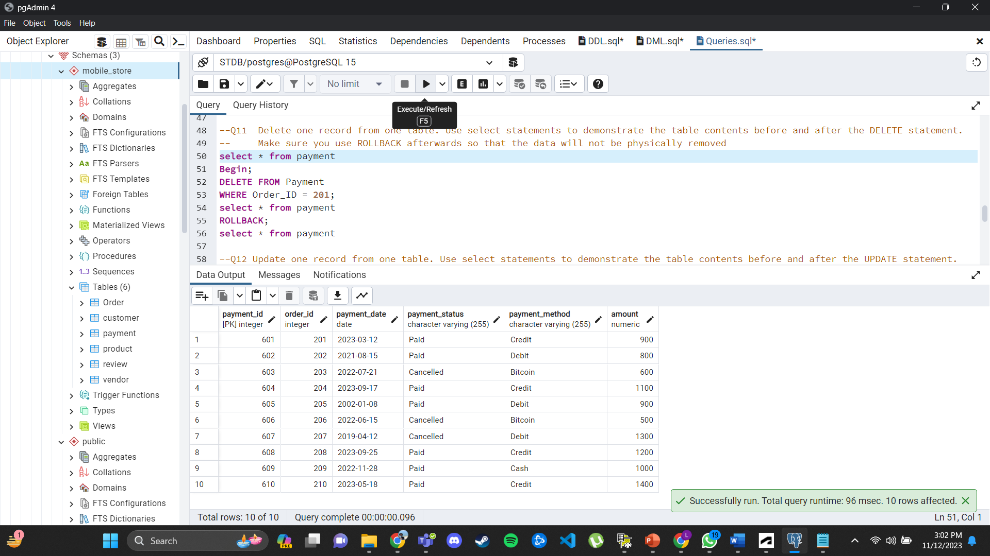

1. After deleting the row

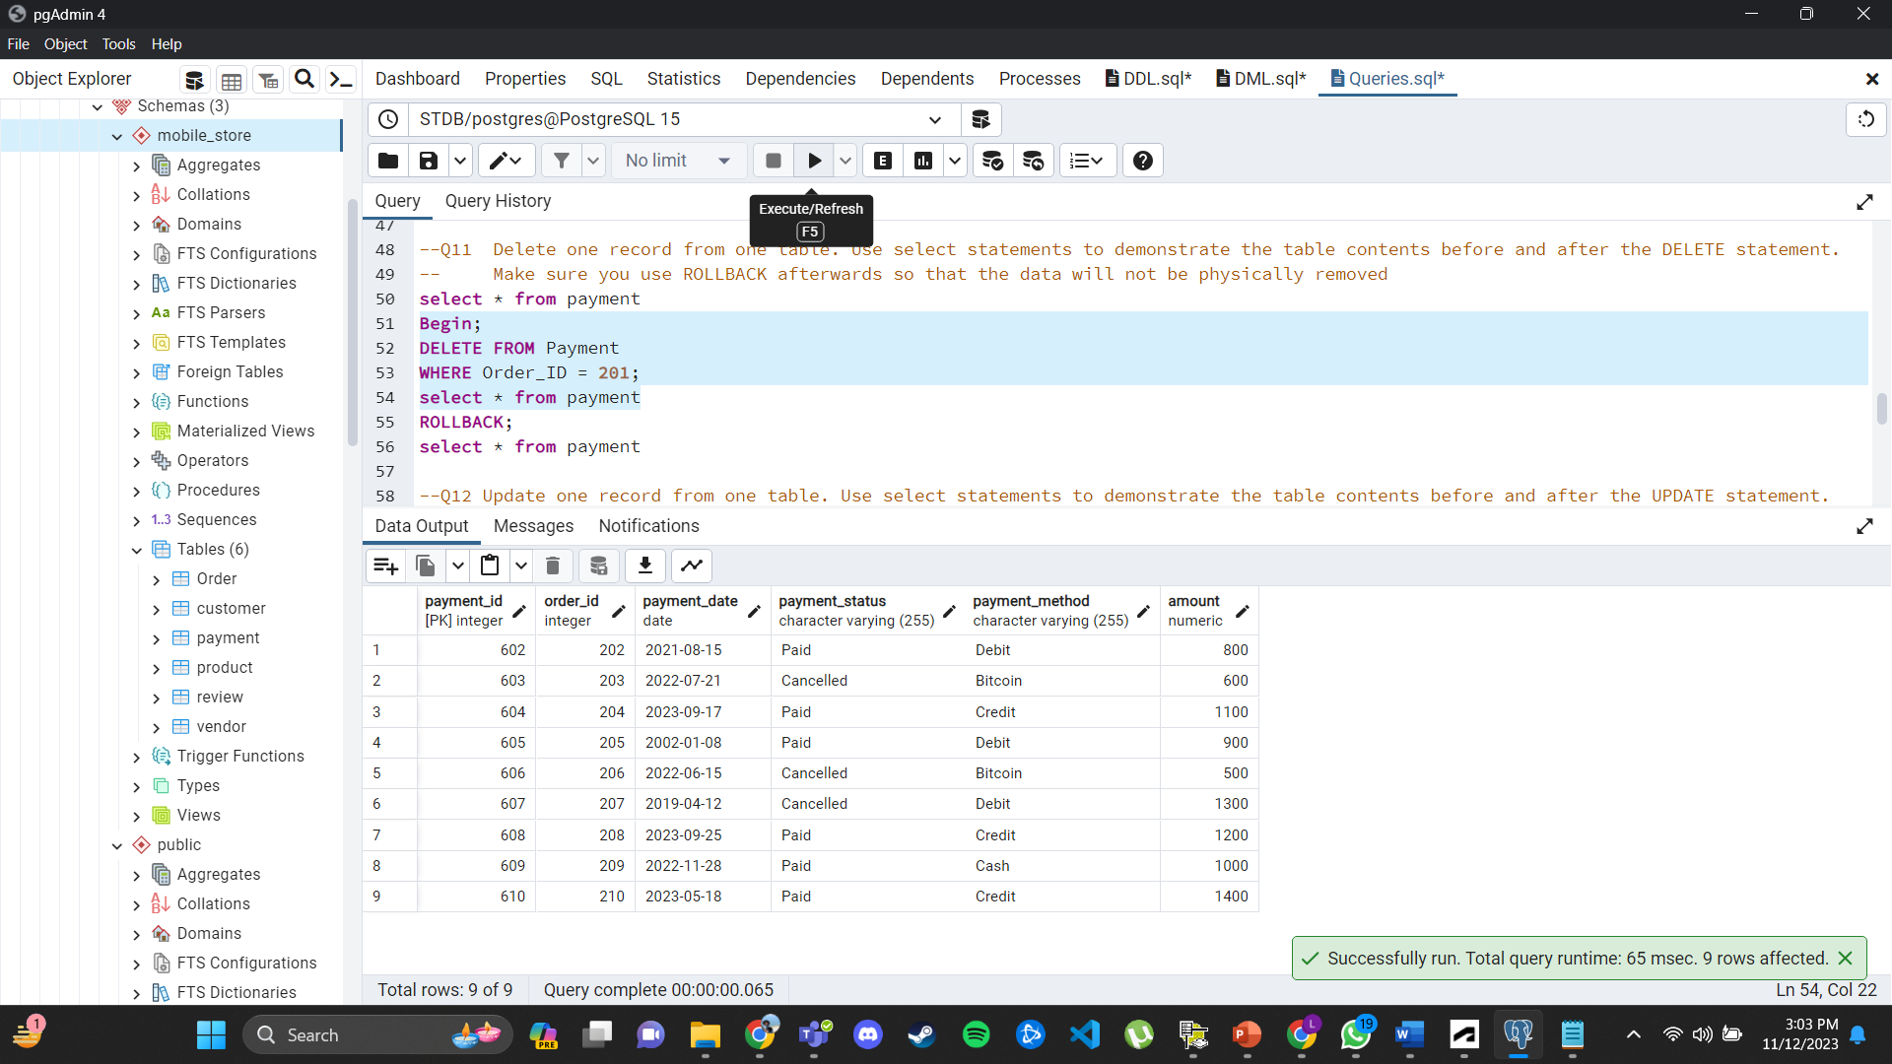

1. Rollback to get the row back

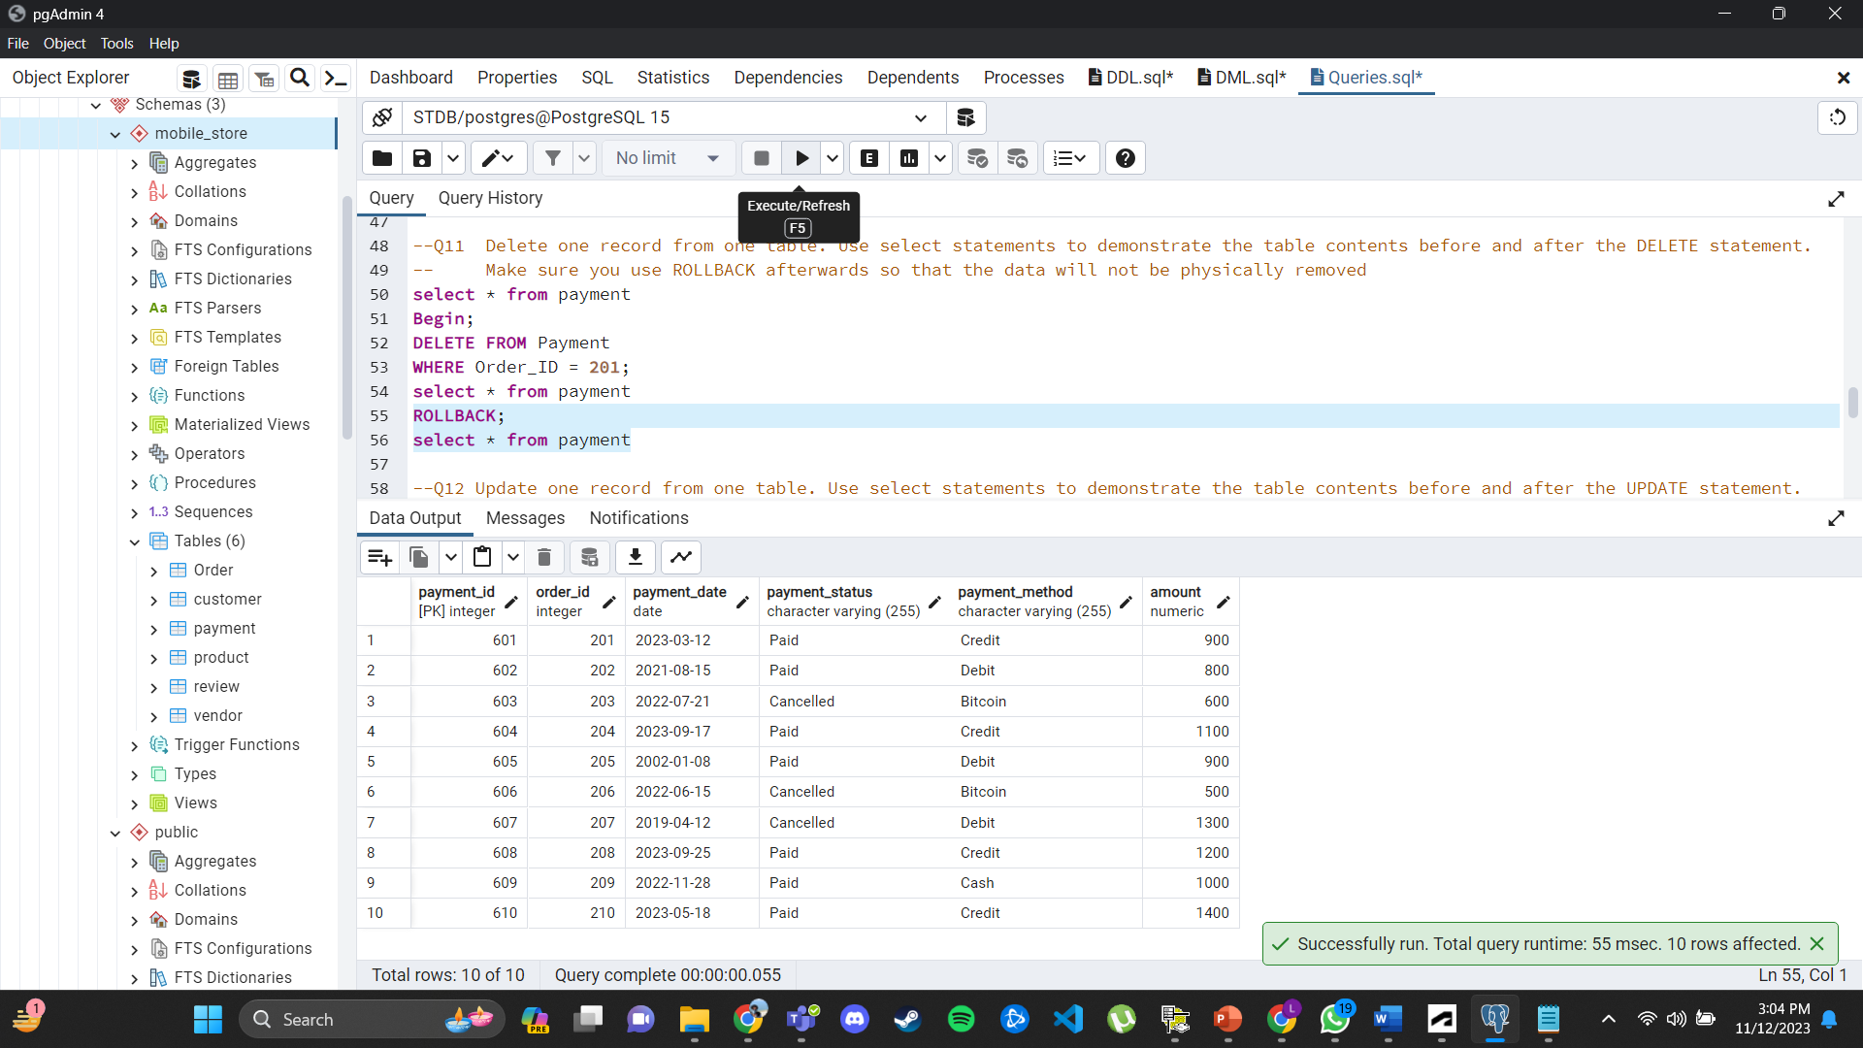

__________________________________________________________________________________

1. Update one record from one table. Use select statements to demonstrate the table contents before and after the UPDATE statement. Make sure you use ROLLBACK afterwards so that the data will not be physically removed
2. Before updating the row

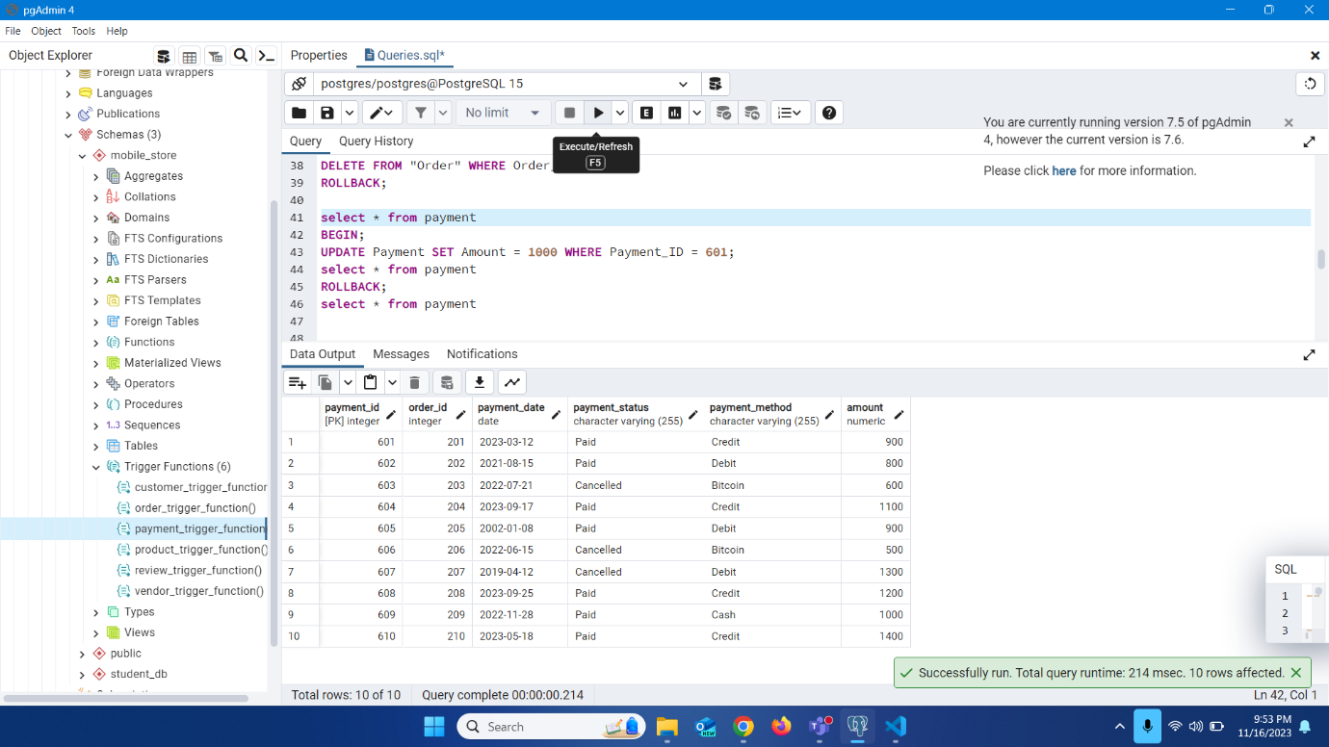

1. After updating the row

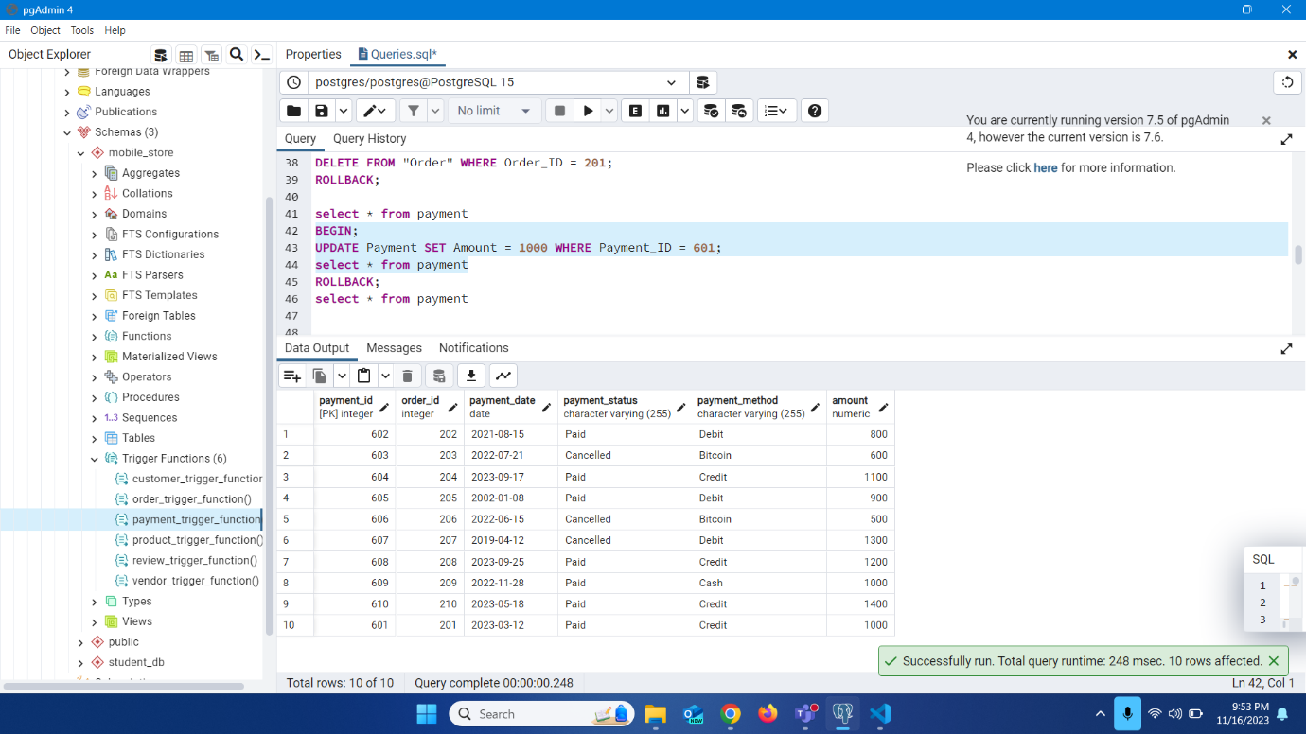

1. Rollback to get the original row back







